**Arizona State University  
IFT458**

M7A2

**Student**

Chih-Chieh Chang

**Professor**

Dinesh Sthapit

November 12, 2022

* Github Link

<https://github.com/DatHarry/458-Project-M7A2>

* loanlist.html

* loanlist.html (live server)

* All LoanLists.pug (pug engine)

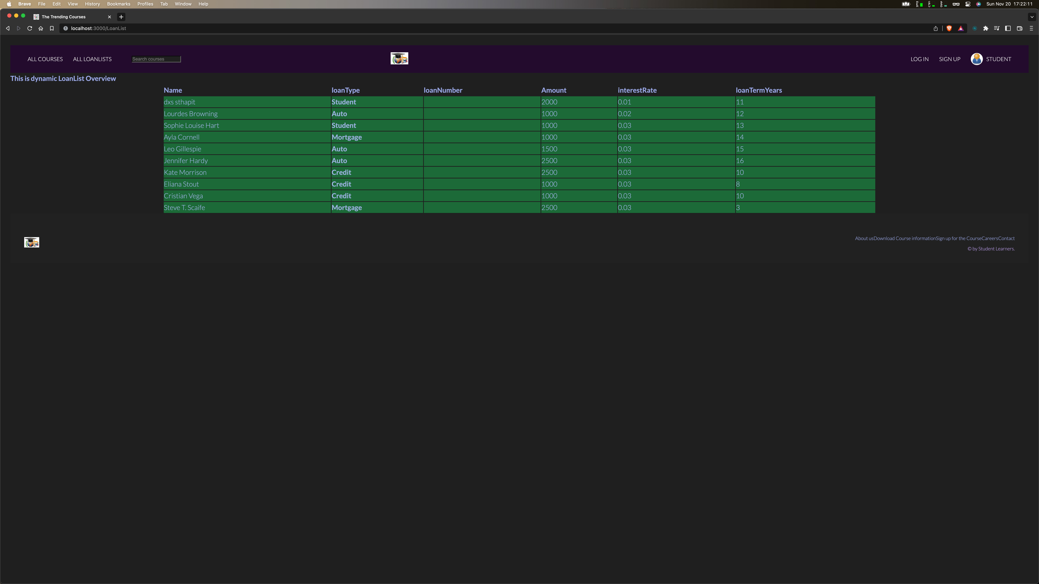

* All LoanLists.pug

